Mockito exercises

WEEK - 2

## Exercise 1: Mocking and Stubbing:

Program:

**MyService.java:**

package com.example.mockito;

public class Myservice {

private Externalapi api;

public Myservice(Externalapi api) {

this.api = api;

}

public String fetchData() {

return api.getData();

}

}

**ExternalApi.java:**

package com.example.mockito;

public interface Externalapi {

String getData();

}

**MyServiceTest.java:**

package com.example.mockito;

import org.junit.jupiter.api.Test;

import static org.junit.jupiter.api.Assertions.assertEquals;

import static org.mockito.Mockito.*;

public class Myservicetest {

@Test

public void testExternalApi() {

Externalapi mockApi = mock(Externalapi.class);

when(mockApi.getData()).thenReturn("Mock Data");

Myservice service = new Myservice(mockApi);

String result = service.fetchData();

assertEquals("Mock Data", result);

}

}

## Output:

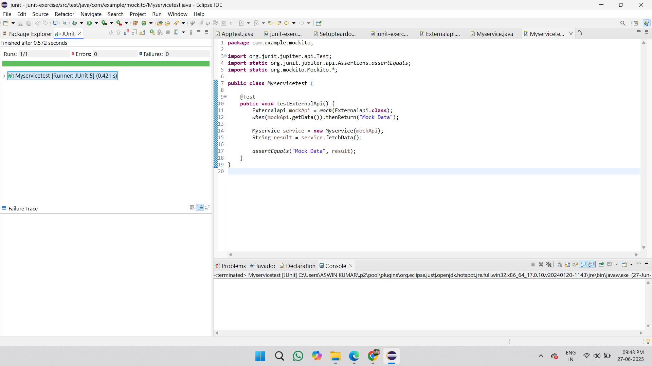

## Exercise 2: Verifying Interactions:

Program:

**ExternalApi.java:**

public interface ExternalApi {

String getData();

}

**MyService.java:**

package com.example.mockito;

import org.junit.jupiter.api.Test;

import static org.junit.jupiter.api.Assertions.assertEquals;

import static org.mockito.Mockito.*;

public class Myservicetest {

@Test

public void testExternalApi() {

Externalapi mockApi = mock(Externalapi.class);

when(mockApi.getData()).thenReturn("Mock Data");

Myservice service = new Myservice(mockApi);

String result = service.fetchData();

assertEquals("Mock Data", result);

}

@Test

public void testVerifyInteraction() {

Externalapi mockApi = mock(Externalapi.class);

Myservice service = new Myservice(mockApi);

service.fetchData();

verify(mockApi).getData();

}

}

**Interaction.java:**

import static org.mockito.Mockito.*;

import org.junit.jupiter.api.Test;

import org.mockito.Mockito;

public class Interaction {

@Test

public void verifyGetDataCalledOnce() {

ExternalApi mockApi = Mockito.mock(ExternalApi.class);

MyService service = new MyService(mockApi);

service.fetchData();

verify(mockApi).getData();

}

}

## Output:

